How to see which shell we are working on/
echo $0
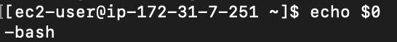
How to check how many shells are in the system?
Cat /etc/shells
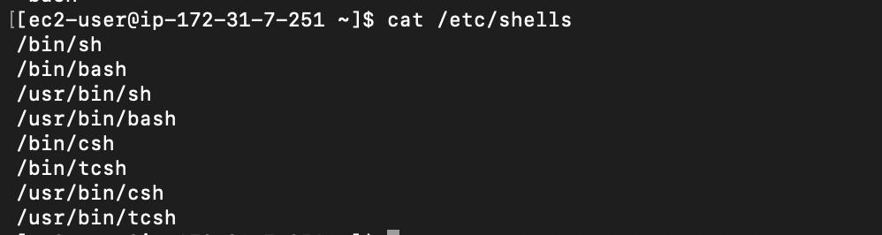
What is kernel?
It acts like interface between hardware and software
User → Application → Shell → Kernel → Hardware
Hardware: CPU, Memory
Kernel: Program
Shell: GUI, Bash
Application: Browser
User: User
Shell and kernel comes in one package called O.S (Operating System)
What is Shell?
Shell acts like an interface between the user and kernel.
Eg: CLI, GUI
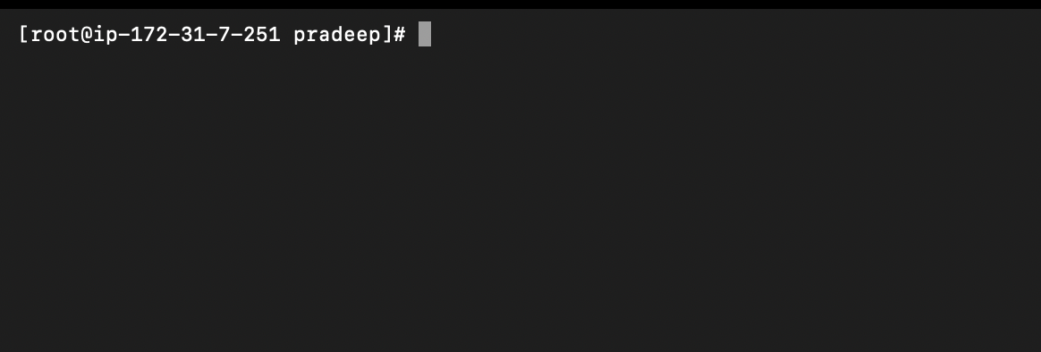
How to run a Script ?
We have 2 ways to run the Script
1) Absolute path: It is path that will map from the starting point to reach the targeted file
Eg: /home/sreevemuri/Assignments/file.txt.
In order to reach the file.txt we need to start from home/sreevemrui/—---/file.txt
2) Relative path: It is a path that can access the file.txt in fewer lines
Eg: cd /home/sreevemuri/filename
How to Execute our Scripts ?
We can do that with the help of 2 ways.
1)./filename
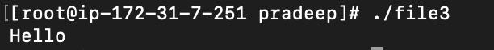
2) bash helloworld
(note: bash is an extension to identify that the script has been written in bash )
What is #!/bin/bash?
It is an interpreter , which helps to translate one language to another language. Eg : Human language to code/computer language.

